**Norwegian teens get a feel for Minnesota**

by [admin](http://www.na-weekly.com/author/admin/) · March 16, 2015

**Norwegian Home Guard Youth enjoy American life as part of NOREX troop exchange**

[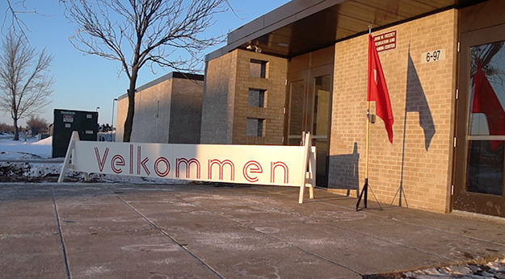](http://www.na-weekly.com/wp-content/uploads/2015/03/The-sign-outside-dining-halldig.jpg)

Photo: Aaron Hagström  
A cheerful sign welcomes Norwegian visitors to the dining hall at Camp Ripley.

Aaron Hagström  
North Oaks, Minn.

Katrine Flunes, 18, a native of Oslo, stood with her hand over her heart in the traditional dress of her home country, as the Norwegian national anthem played. On an overhead screen were the three national flags of the U.S., Norway, and Denmark.

This was the final ceremonial dinner of the 42nd annual American-Norwegian Reciprocal Troop Exchange (NOREX), and Flunes was one of 38 youth that participated in soldiering activities at Camp Ripley in Little Falls, Minnesota, on Feb. 14-22.

The program exchanges cultural and military competence between the two countries; it began in 1974, the year after a historic handshake agreement between the heads of the Minnesota National Guard (MNG) and the Norwegian Home Guard (HV or RRF). This year, 100 Minnesota guardsmen trained in Norway, while the Norwegian Home Guard Youth (HVU) and 56 RRF visited Minnesota.

The HVU is a voluntary organization for Norwegian boys and girls, formally attached to the Norwegian military. None of its training is war-related but rather focuses on sport and outdoor recreation. There are about 94 HVU detachments based across Norway, with roughly 680 youth in all; they have meetings about once per week and field exercises every month or so.

[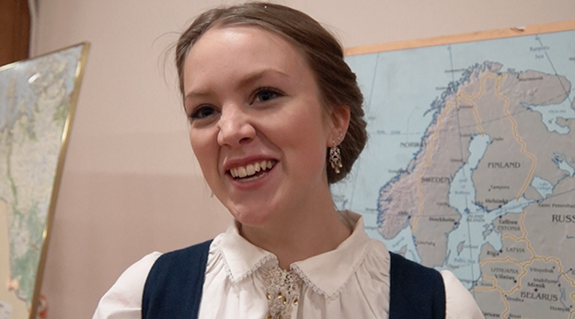](http://www.na-weekly.com/wp-content/uploads/2015/03/Katrine-Flunes-in-bunaddig.jpg)

Photo: Aaron Hagström  
HVU youth Katrine Flunes wearing her bunad. She gave a talk about the traditional dress at the ceremonial dinner concluding NOREX.

The exchange allows young people like Flunes to form an impression of military life while learning about American culture. The RRF conducted military exercises with the local police and sheriffs’ departments and SWAT, as the Youth followed a separate agenda of winter survival training, sledding, land navigation, marksmanship, and a biathlon (which was canceled) under the supervision of Minnesota Guardsmen. The most memorable event, Flunes said, was a flight in a Chinook over Camp Ripley—her first time in a helicopter.

“Many of them will go on to become NCOs or to attend the Military Academy to become commissioned officers,” said Maj. Gen Tor Rune Raabye, commander of the Norwegian Home Guard. “So the consequences of these exchanges are very beneficial for the Norwegian Army.”

The Youth were divided into squads—Red, White, and Blue—and graded on each event. The White Squad won the annual competition and was recognized at an awards ceremony.

Great emphasis was placed on marksmanship. Training began with the Electronic Skills Trainer (EST 2000), a virtual system validated by the U.S. Army Infantry School. Flunes practiced on the range with an M16 assault rifle and Beretta M9 pistol. The top girl and boy in shooting qualifiers were Will Boegeberg and Wilhelm Johansen, who received certificates and a commander’s coin for excellence.

“They do not shoot very much at home; so when they are allowed to train with rifles nearly every day, under the excellent instructors of the Minnesota National Guard, it is a great experience.” Raabye said.

[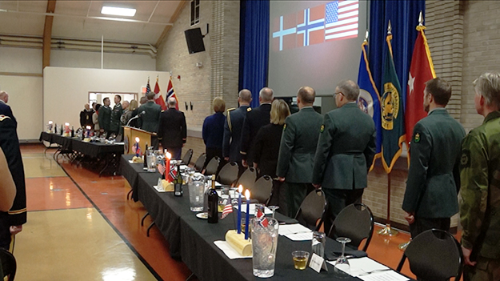](http://www.na-weekly.com/wp-content/uploads/2015/03/Dignitaries-standing-to-national-anthemdig.jpg)

Photo: Aaron Hagström  
Dignitaries from both countries stand for national anthems.

Flunes gave the land navigation course a go; she practiced plotting five points on a map with a compass and protractor, and locating them in the field.

She assisted in building a shelter and starting a fire during winter survival training; Flunes found her cadre leaders’ emphasis on keeping warm surprising.

“Before we had the fire starting, they said go warm up and we said, ‘Are you serious?’” Flunes said. “Back home, we just jump around and do some push-ups to stay warm.”

In a classroom setting, she learned about Operation RYPE, an undercover military operation in the aftermath of World War II that involved Norwegian-American soldiers (many from Minnesota). Flunes said she had never heard about it, but was surprised to find that her family’s cabin in Rjukan is on the opposite side of the valley in which the operation took place.

The last event of her fortnight stay was the “Buddy Weekend,” in which Flunes had a chance to experience Minnesotan culture for two days while staying with a family. She visited Bloomington with her roommate, and stayed with yoga instructor Noelle Racette. They baked chocolate-chip cookies and Norwegian bread and shopped at the Mall of America, where they also rode on the indoor roller coasters.

“They get a feel for Minnesotan culture and for how American young people live,” Raabye said. “They eat American food, which, by the way, is excellent, and some of them probably put on pounds.”

Food, and the seemingly never-ending supply of it, was one cultural difference she found particularly striking, especially during a large American breakfast of pancakes and French toast. Flunes said Norwegians are used to eating small breakfasts, snacking through lunch, and saving room for a big dinner.

“At home, for breakfast, we have just bread, cheese, and maybe some milk and cereal,” Flunes said. “Here there are pancakes and French toast—it’s almost like a dinner.”

[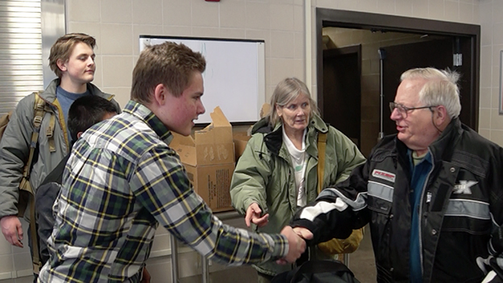](http://www.na-weekly.com/wp-content/uploads/2015/03/Haavard-Fiskaa-meets-Greg-Pappenfusdig.jpg)

Photo: Aaron Hagström  
HVU youth Haavard Fiskaa meets Greg Pappenfus, who was among locals to host the young Norwegians for the final weekend of their visit.

Retired dentist Dr. Greg Pappenfus and wife Joyce took in Johan Saunders-Solbjerg and Adrian Nielsen, to stay at their St. Cloud lake cabin. Next door, the Pappenfuses’ neighbors, dentist Dr. John Collier and wife Carol, took in Arturo Myklebust and Haavard Fiskaa. The four boys went four-wheeling until past midnight on a frozen lake, shopped at sporting goods stores (where they bought hunting knives, caps, t-shirts, and sunglasses) and attended the International Eelpout festival in Walker, Minnesota.

“They had a great time four-wheeling, and used up 5-6 gallons of gasoline,” Pappenfus said. “At the festival, we drove around looking at the fish houses; and then my wife and Carol fixed a turkey and pumpkin pie for dinner.”

The youth part of the program ended with a fashion show, in which Flunes and others showed off the traditional dress (bunads) of Norway. These are rural clothes that vary by region, and some date back to the 18th century; Norwegians commonly wear them at folk dances, weddings, baptisms, and confirmations.

Flunes received her bunad at her confirmation, when she was 14. It was made by her mother and grandmother, and originates in the city of Alta in Northern Norway.

“American guardsmen were really nice and treated us almost like royals,” Flunes said. “They are glad we were their guests.”

*This article originally appeared in the March 20, 2015, issue of the Norwegian American Weekly. To subscribe, visit* [***SUBSCRIBE***](http://www.na-weekly.com/subscribe/) *or call us at (206) 784-4617.*